EFRS Addendum A-03
SHADER-ALS
Integrated Atmospheric Regeneration and Emergency Life-Support Architecture
Parent architectures: EFRS + SHADER + TPV/Radiative Recovery
Document Type | Concept / Proof-of-Concept Technical White Paper
Development Stage | TRL 1–2
Status | Unvalidated experimental architecture
Primary Purpose | Emergency atmospheric off-load / redundant spacecraft life-support
Safety Posture | Atmospheric subsystem physically isolated from battery and energetic cavity

Abstract
SHADER-ALS is a proposed auxiliary life-support branch for the Electrochemical Fuel-Rod Storage (EFRS) and Substrate Housing Atomizing Decoupling Energy Reserve (SHADER) architectures. It investigates whether the energy, power-conditioning capability, and potentially recoverable thermal output associated with a SHADER/EFRS assembly can support an independently isolated atmospheric regeneration cassette during spacecraft contingencies.
The subsystem is not predicated on a battery chemically generating oxygen. Oxygen atoms must originate in an oxygen-bearing feedstock. The baseline POC therefore treats water electrolysis as the reference oxygen-generation pathway and treats carbon-dioxide conversion as a later experimental branch. Plasma, if investigated, is an energy-coupling mechanism rather than a source of matter or free energy.
Chlorine dioxide is excluded from the primary breathing-air loop in this POC because a reactive oxidizing chemistry adds unnecessary contamination and compatibility hazards in a closed spacecraft atmosphere. The architecture instead emphasizes separation, purification, sensing, buffering, fault isolation, and measurable emergency endurance.

1. Relationship to EFRS and SHADER
EFRS packages electrochemical storage into removable, individually monitored rod cartridges connected through a managed power and thermal manifold. SHADER adds a physically distinct radiative/substrate enclosure and a conditioned auxiliary power pathway. SHADER-ALS adds a third function: a serviceable atmospheric module that can receive priority electrical power without becoming part of the battery chemistry or plasma containment volume.
Functional separation:
- EFRS — stored electrochemical reserve and fault-tolerant DC source.
- SHADER — energy coupling, radiative conversion, spectral management, buffering, and reserve decoupling.
- SHADER-ALS — atmospheric cleanup, oxygen generation, gas separation, sensing, and emergency cabin return.

2. Conceptual Physical Arrangement
The atmospheric cassette is positioned beneath or adjacent to the SHADER housing, consistent with the submitted concept sketch, but separated by its own pressure, thermal, electrical, and contamination boundaries. Shared structure does not imply a shared process-gas volume.
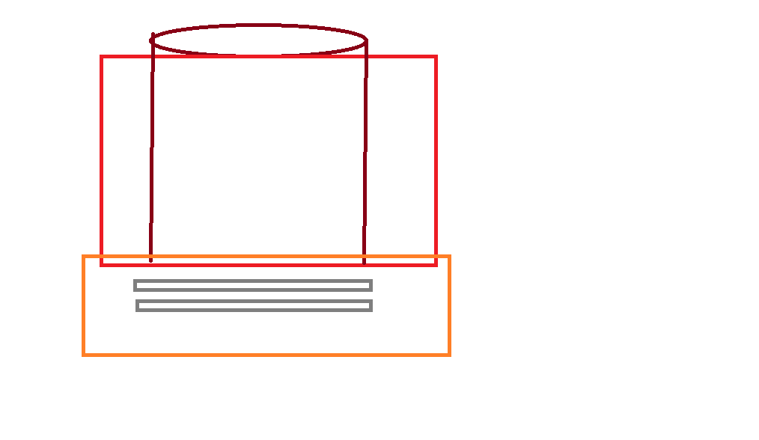
Figure 1. Submitted concept sketch: SHADER/EFRS upper housing with lower atmospheric-service volume.
Conceptual flow: Cabin return → particulate/trace contaminant stage → CO₂ management → oxygen-generation branch → gas separation/purification → oxygen buffer → monitored cabin return. SHADER/EFRS supplies conditioned power to this chain through an independently isolatable life-support bus.

3. Core Research Hypothesis
Can a modular atmospheric cassette integrated mechanically with a SHADER/EFRS energy node provide useful emergency oxygen generation and carbon-dioxide management while remaining sufficiently isolated that a fault in the energy system does not contaminate the cabin atmosphere, and a fault in the atmospheric module does not compromise the energy reserve?
The POC is successful only if this proposition is demonstrated using complete electrical, gas-composition, thermal, and mass-balance measurements.

4. Atmospheric Chemistry Boundaries

4.1 Baseline: water-derived oxygen
Water electrolysis provides the reference architecture: 2 H₂O + energy → 2 H₂ + O₂. The POC treats hydrogen handling as a separate, controlled output stream; it is not returned indiscriminately to the cabin.

4.2 Experimental branch: carbon-dioxide conversion
A later research branch may investigate energy-driven CO₂ splitting, conceptually: CO₂ + energy → CO + ½O₂. This is an energy-consuming reaction and requires downstream separation because carbon monoxide is incompatible with breathable cabin air. The POC does not assume that plasma makes this pathway energetically preferable to conventional life-support methods.

4.3 Excluded primary chemistry
Chlorine dioxide is not part of the baseline oxygen-generation or cabin-recirculation loop. Any future investigation of reactive disinfectants must occur in a separately reviewed, isolated materials/decontamination experiment with no direct route to crew breathing air.

5. System Architecture
SHADER-ALS is electrically downstream of the managed spacecraft/EFRS bus. It does not receive untreated battery gases or plasma process gas. A supervisory controller grants the atmospheric module priority during an emergency and can shed nonessential loads to extend life-support endurance.
Subsystem | POC function
Energy node | EFRS reserve + optional SHADER recovered/conditioned power
Power interface | Protected low-voltage life-support bus with independent isolation
Atmospheric inlet | Simulated cabin-return gas during POC
CO₂ stage | Capture/separation benchmark; conversion is a later branch
O₂ stage | Reference electrolysis module for early testing
Purification | Gas separation and contaminant exclusion before buffer
Buffer | Small monitored oxygen reservoir / equivalent test volume
Return interface | Instrumented simulated-cabin loop; no human exposure in POC

6. Emergency Operating Modes
Mode A — Normal: Primary spacecraft environmental control carries the cabin load. SHADER-ALS remains monitored, isolated, or performs limited standby conditioning.
Mode B — Atmospheric Off-Load: SHADER-ALS accepts a defined fraction of CO₂-management or oxygen-generation demand to reduce load on the primary system.
Mode C — Emergency Sustainment: Nonessential loads are shed and the EFRS reserve prioritizes atmospheric circulation, sensing, CO₂ control, and oxygen generation.
Mode D — Fault Isolation: Any detected contamination, pressure, thermal, electrical, or gas-composition fault closes the cabin interface and places SHADER-ALS in a safe isolated state.

7. Energy and Mass Accounting
Define P_ALS as total atmospheric-module electrical demand, including circulation, electrolysis/conversion, valves, separation, sensing, thermal management, and control. Let E_R be usable EFRS reserve allocated to emergency life support.
Emergency endurance is approximated by:
t_ALS = E_R / P_ALS
This metric must be supplemented by oxygen-production and CO₂-removal limits: electrical endurance alone is not sufficient if gas-processing capacity cannot maintain the simulated cabin within the test envelope.
Additional primary metrics:
- Specific oxygen-generation energy: electrical energy consumed per unit mass of O₂ delivered.
- CO₂ removal rate: mass or molar CO₂ removed per unit time.
- Contaminant breakthrough: CO, residual reactants, or other unwanted species at the return boundary.
- Reserve fraction consumed: EFRS energy used by SHADER-ALS during the test interval.
- Net SHADER contribution: conditioned auxiliary energy delivered to ALS after SHADER auxiliary losses.

8. Instrumentation
- Electrical: bus voltage/current, ALS branch power, EFRS power, SHADER contribution, cumulative energy.
- Atmospheric: O₂ concentration/partial pressure, CO₂ concentration/partial pressure, CO concentration for CO₂-conversion tests, total pressure, humidity, temperature, and flow.
- Thermal: EFRS cartridge temperatures, SHADER wall temperature, ALS electronics/process temperature, inlet/outlet gas temperature.
- Process: water/feedstock consumption, oxygen production, separated by-product quantity, buffer pressure/state.
- Fault state: valve positions, isolation state, controller alarms, sensor validity, and emergency shutdown status.

9. Proof-of-Concept Development Sequence
ALS-0 — Modeling — Electrical reserve, cabin-gas mass balance, heat rejection, and fault-tree modeling.
ALS-1 — Bench circulation loop — Closed inert test loop with sensors, blower, filters, and no oxygen generation.
ALS-2 — Reference oxygen generation — Integrate a small commercial/research electrolysis reference source into the simulated loop; characterize energy per unit O₂.
ALS-3 — CO₂ management — Add a known CO₂ capture/removal stage and quantify removal rate and regeneration demand.
ALS-4 — EFRS interface — Power the isolated atmospheric cassette from a low-energy EFRS demonstrator and characterize reserve endurance.
ALS-5 — SHADER contribution — Add conditioned SHADER output and measure reduction in EFRS draw under identical atmospheric load.
ALS-6 — CO₂ conversion research branch — In a separate sealed test rig, characterize any proposed plasma-assisted CO₂ conversion and its product stream before considering integration.
ALS-7 — Fault demonstration — Simulate sensor, power, flow, and contamination faults and verify automatic isolation.
ALS-8 — Integrated unmanned demonstrator — Operate the complete system against a simulated spacecraft cabin load with no human exposure.

10. Test Matrix
Test | Condition | Measured outcome | Pass criterion
T1 | Baseline circulation | Flow, pressure, sensor stability | Stable closed-loop measurement
T2 | O₂ reference stage | Energy and O₂ output | Reproducible O₂ mass balance
T3 | CO₂ loading | CO₂ inlet/outlet | Quantified removal rate
T4 | EFRS-only emergency | Reserve power and ALS load | Predicted endurance matches measured trend
T5 | EFRS + SHADER | Same ALS load | EFRS draw reduced by measured SHADER contribution
T6 | Power interruption | Bus fault | Atmospheric module enters defined safe state
T7 | Contaminant simulation | Out-of-limit gas reading | Cabin-return path automatically isolated
T8 | Thermal fault | Elevated module temperature | Excitation/process stopped; EFRS remains independently available

11. Safety and Fault Containment
The defining safety rule is double decoupling: the atmosphere is not the SHADER process gas, and the EFRS battery volume is not the breathing-air volume. The atmospheric cassette receives only controlled electrical/thermal interfaces across engineered boundaries.
- No human breathing tests during early POC phases.
- No direct cabin route for plasma exhaust, battery vent gas, hydrogen, carbon monoxide, or experimental reactants.
- Independent valves/isolation at the atmospheric inlet and return.
- Independent shutdown of plasma/excitation, oxygen-generation, and EFRS branches.
- Redundant gas sensing appropriate to the tested chemistry.
- Fire/oxidizer compatibility and materials review before oxygen-enriched operation.
- Fail-safe state is isolation, not continued processing.

12. Success Criteria
The POC succeeds if it demonstrates all of the following:
- Measurable, repeatable oxygen production from a defined oxygen-bearing feedstock.
- Measurable CO₂-management capacity in a simulated closed cabin loop.
- Complete gas mass balance within experimental uncertainty.
- Stable conditioned operation from the EFRS life-support bus.
- Measurable reduction of EFRS draw when valid SHADER auxiliary power is available.
- Automatic isolation following representative atmospheric and energy-system faults.
- No unacceptable heating of the EFRS core.
- No requirement for unexplained energy amplification or matter creation.
- Emergency endurance that can be predicted from measured reserve and ALS demand.

13. Falsification Criteria
SHADER-ALS should be rejected or substantially redesigned if its atmospheric output is too small to justify system mass and complexity; if gas purification cannot reliably prevent harmful by-product breakthrough; if auxiliary energy demand eliminates the intended reserve benefit; if the module materially worsens EFRS thermal safety; or if a conventional independent spacecraft life-support architecture provides superior redundancy at lower mass, power, and risk.

14. Aerospace Integration Rationale
The value proposition is not that a battery becomes a chemical life-support machine. It is that a modular, fault-tolerant energy node can host and prioritize a physically separate emergency atmospheric cassette. For spacecraft, where electrical redundancy and graceful degradation are critical, the integration could reduce duplicated structure or provide an additional survival layer—provided mass, reliability, contamination control, and certification penalties are acceptable.

15. Final Integrated Architecture
Primary spacecraft ECLSS ↔ simulated cabin loop; SHADER-ALS is a parallel emergency branch. EFRS provides reserve power. SHADER may supplement the life-support bus only to the extent its net conditioned output is measured and available. The atmospheric module performs circulation, CO₂ management, reference oxygen generation, purification, buffering, and sensing. Every branch remains independently isolatable.

16. Research Question
Can a mechanically integrated but process-isolated atmospheric regeneration cassette, powered by an EFRS/SHADER energy node, maintain a defined simulated spacecraft atmosphere during loss or off-loading of primary environmental control while providing measurable reserve endurance and safe fault isolation?

17. Conclusion
SHADER-ALS extends EFRS from modular energy storage and SHADER from radiative energy management into a proposed emergency life-support support architecture. Its first experiment should remain deliberately conservative: a simulated cabin, known gas sensors, reference CO₂ management, reference water-derived oxygen generation, a low-energy EFRS supply, and complete energy and mass accounting. Plasma-assisted CO₂ conversion is a later comparative research branch, not a prerequisite.
The milestone is straightforward: demonstrate that the atmospheric cassette can carry a measurable emergency load, quantify how long the reserve can sustain it, and prove that a failure on either side of the energy/atmosphere boundary does not propagate across it.
END OF ADDENDUM A-03
SHADER-ALS — Integrated Atmospheric Regeneration and Emergency Life-Support Architecture

